# TITLE PAGE

**DESIGN AND IMPLEMENTATION OF AN ONLINE MARKETING INFORMATION SYSTEM (CASE STUDY OF KUKOKI COMMUNICATION CENTER, MICHIKA)**

**BY**

**BAPETEL YAKUBU**

**ST/CS/ND/21/134**

**DEPARTMENT OF COMPUTER SCIENCE,**

**SCHOOL OF SCIENCE AND TECHNOLOGY,**

**FEDERAL POLYTECHNIC, MUBI, ADAMAWA STATE.**

**IN PARTIAL FULFILLMENT OF THE REQUIREMENT FOR THE AWARD OF NATIONAL DIPLOMA (ND) IN COMPUTER SCIENCE.**

**SEPTEMBER, 2023**

# DECLARATION

I hereby declare that the work in this project titled **“Design and Implementation of An Online Marketing Information System (case study of Kukoki Communication Center, Michika)”** was performed by me under the supervision of Malam Salihu Gambo Umaru. The information derived from literatures has been duly acknowledged in the text and a list of references provided. The work embodied in this project is original and had not been submitted in part or in full for any other diploma or certificate of this or any other institution.

BAPETEL YAKUBU ________________ _______________

(ST/CS/ND/21/134) Signature Date

# CERTIFICATION

This project titled **“Design and Implementation of An Online Marketing Information System (case study of Kukoki Communication Center, Michika)”** meets the regulations governing the award of National Diploma (ND) in Computer Science, Federal Polytechnic Mubi, Adamawa State

Mal. Salihu Gambo Umaru __________________

(Project Supervisor) Sign/Date

Mr. Mustapha Kassim __________________

(Head of Department) Sign/Date

Mal. Abdulrahman Saidu _________________

(External Examiner) Sign/Date

# DEDICATION

This project is dedicated to my beloved parents for their advice, encouragement and financial support towards my academic pursuit.

# ACKNOWLEDGEMENT

I want to acknowledge Almighty God for his infinite mercy and protection throughout my academic activities. And for the understanding in achieving my academic success.

I also recognize my Supervisor Malam Salihu Gambo Umaru who took time, despite his busy schedule to directed and guided me throughout this research work.

I also acknowledge the Head of Department Computer Science Mr. Mustapha Kassim for his moral encouragement throughout my period of study. I also acknowledge all Staff of Computer Science Department for their support and encouragement and the knowledge they’ve impacted on me throughout our studies.

I also want to appreciate my parent for the love and care and for giving me the opportunity to be trained and achieve my dreams.

Finally, I appreciate the efforts of my Uncles and aunties, for their encouragement and support throughout the course of my study and also my friends and relatives, course mates and all well-wishers. I love you all, may the Almighty God bless you abundantly, Amen.

# TABLE OF CONTENTS

TITLE PAGE i

DECLARATION ii

CERTIFICATION iii

DEDICATION iv

ACKNOWLEDGEMENTS v

TABLE OF CONTENTS vi

LIST OF FIGURES viii

LIST OF TABLES ix

ABSTRACT x

CHAPTER ONE 1

INTRODUCTION 1

1.1 Background to the Study 1

1.2 Problem Statement 2

1.3 Aim and Objectives 2

1.4 Significance of the Study 3

1.5 Scope of the Study 3

1.6 Definition of Some Operational Terms 4

CHAPTER TWO 5

LITERATURE REVIEW 5

2.1 Introduction 5

2.2 Information Systems and Technology 5

2.2.1 Role of Information Systems in Marketing 5

2.2.2 Data-Driven Decision-Making 5

2.2.3 Real-Time Insights 5

2.2.4 Integration of Marketing Channels 6

2.3 Data Management and Databases 6

2.3.1 Importance of Data Management 7

2.3.2 Role of Databases 7

2.3.3 Data Modeling and Normalization 7

2.3.4 Scalability and Performance 7

2.4 Marketing Information Systems 7

2.4.1 Role of Marketing Information Systems in Online Marketing 8

2.4.2 Data Integration and Analysis 8

2.4.3 Customer Relationship Management (CRM) 8

2.4.4 Competitive Intelligence 8

2.5 Information Management System 9

2.5.1 Importance of Information Management Systems 9

CHAPTER THREE 10

SYSTEM DESIGN AND ANALYSIS 10

3.1 Introduction 10

3.2 Disadvantages of the Existing System 10

3.3 Advantages of the Proposed System 10

3.4 The Proposed method 11

3.5 Method of data collection 12

3.6 System Design 12

3.7 System Requirement Specification 19

CHAPTER FOUR 20

RESULTS AND DISCUSSION 20

4.1 Introduction 20

4.2 Results 20

4.3 Discussion 23

4.4 User manual 24

CHAPTER FIVE 25

SUMMARY, CONCLUSION AND RECOMMENDATIONS 25

5.1 Summary 25

5.2 Conclusion 25

5.3 Recommendations 25

5.4 Contribution to Knowledge 26

5.5 Area for Further Work 26

REFERENCES 27

APPENDICES 29

# LIST OF FIGURES

Figure 3.1: Use Case Diagram- - - - - - - - 13

Figure 3.2: System Architecture- - - - - - - - 14

Figure 3.3: Database Entity Relationship Diagram- - - - - - 16

Figure 3.4: Sign Up- - - - - - - - - - 16

Figure 3.5: Sign In form- - - - - - - - - 17

Figure 3.6: Product Display- - - - - - - - - 17

Figure 3.7: All Products- - - - - - - - - 18

Figure 3.8: Report Layout- - - - - - - - - 18

Figure 4.1: Welcome Interface- - - - - - - - 20

Figure 4.2: Login page interface- - - - - - - - 20

Figure 4.3: Registration Interface- - - - - - - - 21

Figure 4.4: Product List Interface- - - - - - - - 21

Figure 4.5: Product Interface- - - - - - - - - 22

Figure 4.6: Cart Interface- - - - - - - - - 22

Figure 4.7: Invoice Interface- - - - - - - - - 23

# LIST OF TABLES

Table 3.1: Login - - - - - - - - - 14

Table 3.2: Products - - - - - - - - - 15

Table 3.3: Category - - - - - - - - - 15

Table 3.4: Sales Table - - - - - - - - - 15

# ****ABSTRACT****

*The dynamic landscape of modern business demands agile and efficient marketing strategies. This study delves into the realm of technology-driven marketing solutions through the "Design and Implementation of an Online Marketing Information System." It presents a detailed case study focusing on Kukoki Communication Center, illustrating the transformative power of an online platform tailored to meet the center's specific marketing needs. The research encompasses the development and deployment of a comprehensive Online Marketing Information System, designed to enhance marketing operations, customer engagement, and data-driven decision-making. This system provides tools for campaign management, customer interaction tracking, and performance analytics, offering a holistic approach to modern marketing. In conclusion, the successful implementation of this system at Kukoki Communication Center signifies a significant milestone in elevating marketing strategies. It fosters efficient marketing practices, strengthens customer relationships, and empowers decision-makers with valuable insights. This project not only underscores the pivotal role of technology in marketing but also serves as an instructive reference for organizations aiming to harness the digital age's marketing potential.*

# CHAPTER ONE

# INTRODUCTION

## 1.1 Background to the Study

In the rapidly evolving landscape of business, the role of marketing has transformed significantly. The advent of digital technologies has propelled the shift from traditional marketing approaches to online marketing, where businesses utilize digital platforms to promote their products and services. Online marketing offers unprecedented opportunities for targeting, engaging, and analyzing consumer behavior, making it an indispensable aspect of modern business strategies (Laudon, 2020).

In recent years, the business landscape has undergone a digital transformation, driven by rapid advancements in technology and changing consumer behavior. This transformation has revolutionized the way companies approach marketing. Traditional marketing approaches, while still relevant, are now complemented and often superseded by online marketing strategies. Online marketing, also known as digital marketing, encompasses a wide range of activities conducted through digital channels such as social media, search engines, email, and websites. This shift has led to the need for comprehensive and efficient systems that can manage and analyze the complexities of online marketing campaigns (Kotler & Keller, 2016).

The rise of online marketing can be attributed to several factors, including the increased accessibility of the internet, the proliferation of mobile devices, and the shift in consumer preferences towards online shopping and engagement. As consumers spend more time online, businesses have recognized the potential of digital platforms to reach their target audiences more effectively and efficiently. This has led to a significant increase in digital advertising budgets across industries. To harness the potential of online marketing effectively, businesses require robust information systems that facilitate data collection, analysis, and decision-making. An Online Marketing Information System (OMIS) serves as the backbone of these efforts, enabling companies to streamline their marketing activities, track campaign performance, and optimize strategies based on real-time insights (Wang, Liu, & Lee, 2021).

The dynamic nature of online marketing presents both opportunities and challenges. On one hand, businesses have access to a wealth of data and analytics that can provide valuable insights into consumer behavior, campaign performance, and market trends. On the other hand, managing multiple online marketing channels, analyzing vast amounts of data, and staying updated with the ever-changing digital landscape can be overwhelming without proper tools and systems in place. As businesses navigate this dynamic landscape, the need for a dedicated Online Marketing Information System (OMIS) becomes increasingly evident. An OMIS serves as a central platform for businesses to manage their online marketing efforts cohesively. It facilitates data collection, analysis, and reporting, allowing businesses to make data-driven decisions and optimize their marketing strategies. Such a system also enables collaboration among marketing teams, ensuring seamless coordination and efficient utilization of resources (Wind & Mahajan, 2017).

## 1.2 Problem Statement

Despite the growing significance of online marketing, many businesses struggle to harness its full potential due to the absence of well-designed information systems tailored to their needs.

1. Fragmented Data: Businesses engage in multiple online marketing channels, such as social media platforms, search engines, email campaigns, and more.
2. Lack of Real-Time Insights: Traditional marketing practices often lack real-time feedback on campaign performance. In contrast, online marketing campaigns generate real-time data, necessitating systems capable of capturing and presenting these insights in a timely manner.
3. Complex Analytics: The sheer volume of data generated by online marketing campaigns demands advanced analytics capabilities.
4. Inefficient Collaboration: Online marketing often involves cross-functional teams working on different aspects of a campaign.
5. Customization Needs: Each business has its own unique marketing goals, target audiences, and strategies.

## 1.3 Aim and Objectives

The aim of this study is to design and implement an Online Marketing Information System (OMIS). The specifics objectives are to:

1. Develop a user-friendly interface for managing online marketing campaigns.
2. Implement robust data collection mechanisms to gather relevant marketing metrics.
3. Incorporate advanced analytics capabilities to derive actionable insights.
4. Enable real-time monitoring of campaign performance.
5. Facilitate seamless collaboration among marketing teams.

## 1.4 Significance of the Study

The proposed research on the design and implementation of an Online Marketing Information System (OMIS) holds substantial significance for businesses, marketers, and the broader field of digital marketing. This study addresses critical gaps in the current online marketing landscape and offers solutions that can bring about transformative changes in the way businesses approach their digital marketing efforts.

The development of an OMIS will empower businesses to make informed decisions based on real-time data and insights. By having access to comprehensive and up-to-date information about campaign performance, customer behaviors, and market trends, businesses can adjust their strategies promptly and allocate resources effectively. This ability to pivot quickly in response to emerging trends and changing consumer preferences is crucial for maintaining a competitive edge in today's fast-paced digital environment

The OMIS equips businesses with the tools to stay ahead of the competition. By monitoring market trends, tracking competitor activities, and gaining insights into consumer preferences, businesses can devise innovative marketing strategies that resonate with their target audience. This competitive advantage can lead to increased brand visibility, customer loyalty, and market share. Online marketing is all about engaging customers effectively across digital platforms. The OMIS allows businesses to analyze customer behaviors, preferences, and responses, enabling them to tailor their marketing messages and campaigns to specific segments. This personalization fosters stronger customer relationships and enhances engagement, resulting in higher conversion rates and brand loyalty.

## 1.5 Scope of the Study

The scope of this study revolves around the design and implementation of an Online Marketing Information System (OMIS) to address the challenges faced by businesses in effectively managing their online marketing campaigns. The study will encompass various aspects, including the technical, functional, and operational dimensions of the proposed OMIS.

The technical scope of the study involves the development of a robust and scalable OMIS that can accommodate diverse online marketing channels, such as social media, search engines, email marketing, and more. The system will be designed to gather, aggregate, and analyze data from these channels in real time, providing insights into campaign performance, audience engagement, and other relevant metrics. The system will offer customization options to cater to the specific needs and preferences of different businesses, industries, and campaign types.

## 1.6 Definition of Some Operational Terms

**Database**: A database is an organized collection of structured data stored in a computer system (Connolly & Begg, 2015).

**Information**: It provides valuable insights, knowledge, or understanding that can guide decision-making, problem-solving, and actions (O'Brien & Marakas, 2016).

**Management**: Management refers to the process of planning, organizing, directing, and controlling resources and activities within an organization to achieve specific goals and objectives (Daft, 2017).

**Marketing**: It involves a range of activities, including product development, pricing, promotion, distribution, and customer relationship management (Kotler & Keller, 2016).

**System**: the context of information technology, a system often refers to a combination of hardware, software, data, processes, and people that collaborate to perform tasks or functions (Laudon, 2016).

# CHAPTER TWO

# LITERATURE REVIEW

## 2.1 Introduction

This chapter provides an overview of the theoretical concepts and literatures that will guide the design and implementation of the Online Marketing Information System (OMIS). Discuss the importance of these concepts in shaping the system's functionality and objectives.

## 2.2 Information Systems and Technology

The integration of information systems and technology has become fundamental to modern business operations and decision-making. Information systems encompass a wide range of hardware, software, data, processes, and people that work together to facilitate data collection, storage, processing, and dissemination. In the context of marketing, leveraging information systems and technology is crucial for optimizing online marketing efforts, tracking campaign performance, and making data-driven decisions (Laudon, 2020).

## 2.2.1 Role of Information Systems in Marketing

Information systems play a pivotal role in streamlining marketing activities and improving overall efficiency. Through integrated data collection, storage, and analysis, these systems enable marketers to gain insights into customer behaviors, preferences, and interactions across various online platforms. This enables businesses to tailor their marketing strategies to align with consumer needs and preferences, ultimately enhancing customer engagement and satisfaction (O'Brien & Marakas, 2017).

## 2.2.2 Data-Driven Decision-Making

The advent of information systems has revolutionized decision-making processes in marketing. By harnessing data from online marketing campaigns, businesses can make informed decisions about their strategies, resource allocation, and targeting. Data-driven decision-making ensures that marketing efforts are aligned with actual consumer trends and preferences, leading to more effective campaigns and improved return on investment (ROI) (Chaffey & Smith, 2021).

## 2.2.3 Real-Time Insights

One of the significant advantages of information systems in marketing is the ability to provide real-time insights. Online marketing campaigns generate a continuous stream of data, such as clicks, impressions, and user interactions. Information systems process and present this data in real time, enabling marketers to monitor campaign performance and make immediate adjustments as needed. Real-time insights allow businesses to capitalize on emerging trends and optimize strategies promptly (Strauss & Frost, 2019).

## 2.2.4 Integration of Marketing Channels

Information systems facilitate the integration of diverse marketing channels, including social media, email marketing, search engine optimization (SEO), and pay-per-click advertising. These systems enable marketers to view and manage campaigns across multiple platforms from a centralized dashboard. This integration promotes consistency in messaging, enhances user experiences, and improves cross-channel coordination (Kaplan & Haenlein, 2020).

## 2.3 Data Management and Databases

Efficient data management and well-structured databases are integral to the successful operation of an Online Marketing Information System (OMIS). These elements provide the foundation for storing, organizing, and retrieving the vast amount of data generated by online marketing campaigns (Connolly & Begg, 2015).

Database Management Systems (DBMS) are essential tools for storing, organizing, managing, and retrieving data efficiently. DBMS provide a structured approach to store and retrieve data, ensuring data integrity, security, and scalability for organizations. Recent studies have highlighted the significance of DBMS in various domains. A research article by Ramakrishnan and Gehrke (2020), emphasized that DBMS are crucial for managing the increasing volumes of data generated in today's digital world. The study highlighted that DBMS enable organizations to handle diverse data types, ensure data consistency, and support complex data queries. One of the key functions of DBMS is data storage and organization. DBMS provide a structured framework for storing data in tables, defining relationships between tables, and enforcing data integrity through constraints. These systems often employ relational models, such as the widely-used SQL (Structured Query Language), to manage data in a tabular format. A study by Elmasri and Navathe (2019), emphasized that DBMS enable efficient data storage, normalization, and indexing to optimize data retrieval performance.

Moreover, DBMS offer tools for data retrieval and manipulation. These systems allow users to query the database using SQL or other query languages to retrieve specific data based on specified criteria. DBMS also support complex operations such as joining multiple tables, filtering data, and aggregating results. A research article by Rizvi et al. (2021) highlighted the role of DBMS in enabling efficient and accurate data retrieval, facilitating decision-making and analysis. DBMS also provide mechanisms for data security and access control. These systems enable organizations to define user roles and permissions, ensuring that only authorized users can access and modify the data. DBMS also offer features such as data encryption, backup, and recovery to protect against data breaches and system failures. A study by Motahari-Nezhad et al. (2021) emphasized the importance of DBMS in ensuring data privacy, integrity, and availability, particularly in the context of sensitive and regulated data.

The advent of advanced technologies has further enhanced the capabilities of DBMS. Distributed DBMS enable data storage and processing across multiple servers, providing scalability, fault tolerance, and high availability. NoSQL (Not Only SQL) DBMS have emerged as alternatives to traditional relational DBMS, offering flexible data models and scalability for handling large volumes of unstructured and semi-structured data. A research article by Ghazal *et al.* (2020), discussed the benefits and challenges of NoSQL DBMS in big data environments.

## 2.3.1 Importance of Data Management

Data management involves the process of collecting, storing, organizing, and ensuring the quality of data. In the context of an OMIS, effective data management ensures that relevant marketing data from various channels are collected systematically, preventing data fragmentation and ensuring data accuracy (Elmasri & Navathe, 2015).

## 2.3.2 Role of Databases

Databases serve as repositories for structured data, enabling efficient storage, retrieval, and manipulation. A well-designed database for the OMIS is crucial for organizing and structuring data related to campaign performance metrics, user interactions, customer demographics, and more (Kroenke & Auer, 2016).

## 2.3.3 Data Modeling and Normalization

Data modeling involves the process of designing the structure of a database to represent the relationships among data entities. Normalization, a key principle in database design, ensures that data is organized without redundancy or data anomalies. Applying data modeling and normalization techniques to the OMIS database enhances data integrity and consistency (Chen, 2017).

## 2.3.4 Scalability and Performance

Scalability is a critical consideration in database design, especially in the context of an OMIS that deals with diverse online marketing data. Proper database design ensures that the system can accommodate growing volumes of data and maintain optimal performance as the user base expands (Codd, 2019).

## 2.4 Marketing Information Systems

Marketing Information Systems (MkIS) are critical components of modern business operations, enabling organizations to gather, analyze, and utilize marketing-related data for strategic decision-making and improved campaign effectiveness. Marketing Information Systems serve as the backbone for managing the complexities of marketing activities, allowing businesses to stay competitive in the ever-evolving digital landscape (Kotler & Keller, 2016).

## 2.4.1 Role of Marketing Information Systems in Online Marketing

Marketing Information Systems facilitate the collection, integration, storage, and analysis of marketing data from various sources, including online platforms. In the context of online marketing, Marketing Information Systems play a crucial role in capturing user interactions, campaign performance metrics, customer feedback, and market trends. Marketing Information Systems enable businesses to gain valuable insights into consumer behaviors, preferences, and engagement patterns across online channels. These insights empower marketers to tailor their strategies to specific target segments, leading to more personalized and effective campaigns (McDaniel & Gates, 2017).

## 2.4.2 Data Integration and Analysis

One of the key functions of Marketing Information Systems is the integration of data from multiple sources. Online marketing involves diverse channels such as social media, email, paid search, and more. Marketing Information Systems consolidate data from these channels into a centralized platform, providing a holistic view of marketing efforts. Advanced analytics tools within Marketing Information Systems enable businesses to derive actionable insights from the collected data. Through data visualization, trend analysis, and predictive modeling, marketers can uncover patterns and correlations that guide their decision-making (Wind & Mahajan, 2017).

## 2.4.3 Customer Relationship Management (CRM)

Marketing Information Systems often incorporate Customer Relationship Management (CRM) functionalities to enhance customer interactions and relationships. CRM modules within the system allow businesses to track customer interactions, manage leads, and tailor marketing communications based on customer preferences and behaviors (Sheth & Sharma, 2015).

## 2.4.4 Competitive Intelligence

Marketing Information Systems also contribute to competitive intelligence by monitoring competitor activities, market trends, and industry developments. By analyzing data on competitors' online marketing strategies, businesses can identify opportunities and threats, enabling them to adapt their own strategies accordingly (Kaplan & Haenlein, 2020).

## 2.5 Information Management System

An information management system (IMS) is a comprehensive framework that encompasses the processes, technologies, and strategies used to collect, organize, store, retrieve, and analyze information within an organization. An information management system refers to the integrated set of processes, tools, and technologies that enable organizations to effectively manage their information assets. It includes various components such as data collection, storage, retrieval, analysis, and dissemination (Khumalo, 2020).

## 2.5.1 Importance of Information Management Systems

1. Decision Making and Strategic Planning IMS enables organizations to gather and analyze relevant data, providing valuable insights that support informed decision-making and strategic planning (Delen, 2021). By providing accurate and up-to-date information, IMS enhances the ability of managers to make informed decisions in a timely manner.
2. Improved Efficiency and Productivity Efficient information management improves operational efficiency and productivity. By centralizing information, eliminating duplication, and automating processes, IMS streamlines workflows, reduces manual effort, and enhances overall efficiency (Wang, Liu, & Lee, 2021).
3. Enhanced Collaboration and Knowledge Sharing IMS facilitates effective collaboration and knowledge sharing within organizations. It provides a centralized platform for employees to access and share information, fostering collaboration, and enabling knowledge transfer (Al-Khouri & Abu-Jarour, 2020).

# CHAPTER THREE

# SYSTEM DESIGN AND ANALYSIS

## 3.1 Introduction

This chapter contains the system design, the disadvantages of the existing system, the advantages of the proposed system over the existing system, the system requirements (Hardware and Software), the design and the system architecture.

## 3.2 Disadvantages of the Existing System

The existing system for Online Marketing Information System has several disadvantages that can hinder its efficiency and effectiveness. Here are some potential disadvantages:

1. Manual Data Handling: The existing system relies heavily on manual data handling, making it prone to errors and inefficiencies in data management.
2. Limited Analytics: The current system lacks real-time analytics capabilities, hindering the ability to analyze campaign performance promptly.
3. Ineffective Targeting: Without advanced targeting features, the existing system may result in marketing efforts that are less precise and less likely to reach the right audience.
4. Time-Consuming Tasks: Marketers often spend considerable time on repetitive and manual tasks, such as sending individual emails or managing social media posts.
5. Higher Operational Costs: The inefficiencies and manual processes in the existing system can lead to higher operational costs over time.
6. Limited Scalability: The current system may struggle to handle increased data volumes and complexity as marketing efforts grow.

## 3.3 Advantages of the Proposed System

The proposed Online Marketing Information System offers a range of advantages over the existing manual system, enhancing efficiency, communication, and user experience. Here are some potential advantages:

1. Efficient Data Management: The proposed OMIS provides efficient data management capabilities, allowing marketers to easily store, retrieve, and analyze data related to marketing campaigns, customer interactions, and sales.
2. Real-time Analytics: The system offers real-time analytics and reporting, enabling marketers to make data-driven decisions promptly. This leads to better campaign optimization and quicker responses to market trends.
3. Improved Targeting: The system incorporates advanced targeting algorithms, helping marketers reach their intended audience more effectively.
4. Automation: OMIS automates various marketing tasks, such as email campaigns, social media posting, and ad management. This reduces manual workload and enhances productivity.
5. Cost Reduction: By streamlining marketing processes and reducing manual labor, the proposed system can lead to cost savings in terms of labor and resources.
6. Scalability: OMIS is designed to scale with the organization's needs. As the marketing efforts grow, the system can accommodate increased data and campaign complexity.

## 3.4 The Proposed method

The Waterfall Model is a classic software development methodology that consists of distinct phases, each building upon the outputs of the previous phase. Below is a representation of the Waterfall Model adapted for the proposed Online Marketing Information System:

**Requirements Gathering and Analysis:**

1. Gather detailed requirements from stakeholders, including students, faculty, and administrators.
2. Define the scope, objectives, and functionalities of the system.
3. Analyze existing systems and processes to identify shortcomings and improvement opportunities.

**System Design:**

1. Design the overall architecture of the system, including the database structure, user interfaces, and notification system.
2. Create wireframes or mockups to visualize the user interfaces and interactions.
3. Define the data model, specifying the relationships between entities and attributes.
4. Plan the lecture scheduling algorithm and notification generation process.

**Implementation:**

1. Develop the front-end interfaces for users using appropriate web technologies.
2. Create the back-end components, including the database, scheduling algorithm, and notification engine.
3. Implement user authentication and access control mechanisms to ensure data security.
4. Integrate notification options.

**Testing:**

1. Conduct unit testing to ensure individual components function correctly.
2. Perform integration testing to validate the interactions between different modules.
3. Execute system testing to ensure that the complete system meets the specified requirements.
4. Validate the lecture scheduling algorithm's accuracy and efficiency.

**Maintenance:**

1. Monitor the system's performance, addressing any bugs or issues that arise post-deployment.
2. Gather user feedback and continuously refine the system based on evolving needs.
3. Implement updates, enhancements, and feature additions as required by the department.
4. Ensure data backups and disaster recovery mechanisms are in place.

## 3.5 Method of data collection

There are two main sources of data collection in carrying out this study, information was basically obtained from the two sources which are:

**Primary Source:** In my research I used the interview method for my primary source of Information; this is done by asking question from the different departments. We also used a method of observation where we were attentive to all the activities of the departmental classes, studying their activities and recording them down on daily basis or as required.

**Secondary Source:** The need for the secondary sources of data for this kind of project cannot be over emphasized. The secondary data were obtained by me from magazines, Journal, newspapers, library source and from other sources. Most of the information from the library research has been covered in my literature review in the previous chapter of this project.

## 3.6 System Design

Systems design is the process of defining the architecture, modules, interfaces, and data for a system to satisfy specified requirements. Systems design could be seen as the application of systems theory to product development.

## 3.6.1 Algorithm diagram

**Use Case Diagram**

Login

Add Category

Registration

Add Product

Admin

Add User

View Sales

View Receipt

Logout

User

Figure 3.1: Use Case Diagram

## 3.6.2 System Architecture

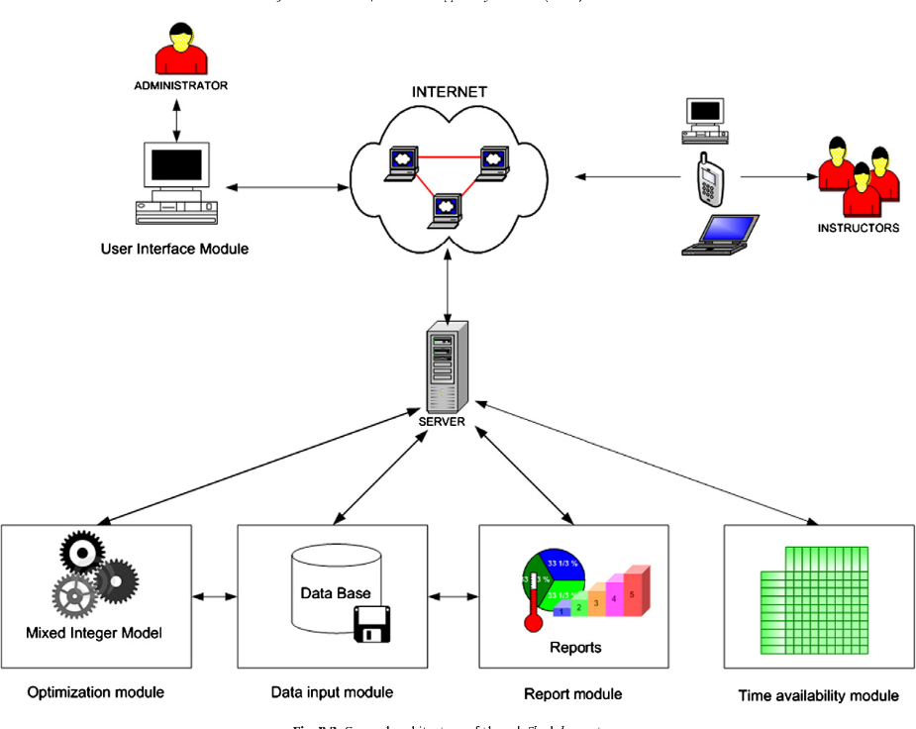

Figure 3.2: System Architecture

## 3.6.3 Database Tables/Queries Structures

Below are the database table for the new system.

**Table 1: Login Table**

**Top of Form**

| **Name** | **Type** | **Extra** |
| --- | --- | --- |
| **id Primary** | int(11) | AUTO_INCREMENT |
| **Email** | varchar(50) |  |
| **Password** | varchar(50) |  |
| **type** | varchar(50) |  |
| **firstname** | varchar(50) |  |
| **lastname** | varchar(50) |  |
| **Address** | varchar(50) |  |
| **Contact_info** | varchar(50) |  |
| **photo** | varchar(50) |  |
| **Status** | varchar(50) |  |
| **Activation code** | varchar(50) |  |
| **Reset code** | varchar(50) |  |
| **Created_on** | varchar(50) |  |

**Table 2: Products Table**

Top of Form

| **Name** | **Type** | **Extra** |
| --- | --- | --- |
| id Primary | int(11) | AUTO_INCREMENT |
| Category_id | int(11) |  |
| name | varchar(250) |  |
| description | varchar(250) |  |
| price | varchar(250) |  |
| counter | varchar(250) |  |
| photo | varchar(250) |  |
| date | timestamp |  |

Bottom of Form

**Table 3: Category Table**

Top of Form

| **Name** | **Type** | **Extra** |
| --- | --- | --- |
| id Primary | int(11) | AUTO_INCREMENT |
| name   Index | varchar(250) |  |
| Date | timestamp |  |

Bottom of Form

Bottom of Form

**Table 4: Sales Table**

Top of Form

| **Name** | **Type** | **Extra** |
| --- | --- | --- |
| id Primary | int(11) | AUTO_INCREMENT |
| User_id   Index | varchar(250) |  |
| Pay_id | varchar(250) |  |
| Sales_date | timestamp |  |

Bottom of Form

Bottom of Form

## 3.6.4 Database Entity Relationship Diagram

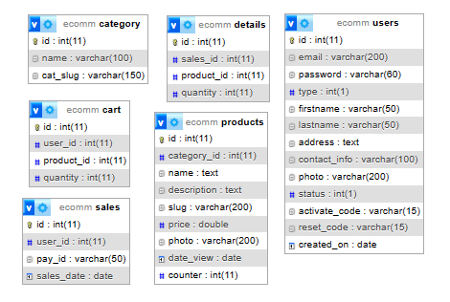

Figure 3.3: Database Entity Relationship Diagram

## 3.6.5 Input and Output Design

**REGISTRATION**

First Name

Last Name

Email Address

Password

Re-type Password

I’m not a robot

**SIGN UP**

Figure 3.4: Sign Up

**SIGN IN**

Email

Password

**SIGN IN**

Figure 3.5: Sign In form

**PRODUCT DISPLAY**

**Add to Cart**

**+**

**-**

Figure 3.6: Product Display

**ALL PRODUCTS**

Product

Product

Product

Product

Product

Product

Figure 3.7: All Products

**3.6.6 Report Layout**

# YOUR CART

|  | **Photo** | **Name** | **Price** | **Quantity** | **Subtotal** |
| --- | --- | --- | --- | --- | --- |
|  | http://localhost/ecommerce/images/samsung-galaxy-s9-128-gb.jpg | Samsung Galaxy S9+ [128 GB] | N 80,089.99 |  | N240,269.97 |
|  | http://localhost/ecommerce/images/samsung-note-8.jpg | Samsung Note 8 | N82,000.00 |  | N82,000.00 |
| **Total** | | | | | **322,269.97** |
|  |  |  |  |  |  |

Figure 3.8: Report Layout

## 3.7 System Requirement Specification

## 3.7.1 Hardware Requirements

The software to be design needs the following hardware for an effective operation of the newly designed system.

1. A system running on intel, P(R) duo core with higher processor
2. The-Random Access Memory (RAM) should be at least 512MB.
3. At least 20-GB hard disk.
4. A monitor.

## 3.7.2 Software Requirements

The software requirements include:

1. A window 7 or higher version of operating system.
2. XAMP or WAMP for Database
3. PHP
4. MySQL
5. Browser

## 3.7.3 Personnel Requirement

Any computer literate who has a technical knowhow of internet surfing can use the system because it is user friendly.

# CHAPTER FOUR

# RESULTS AND DISCUSSION

## 4.1 Introduction

The new system is designed using PHP and MySQL programming language for easy records inserting and updating. This system will help in managing and easily retrieving of information from the system for management purposes.

## 4.2 Results

## 4.2.1 Welcome Interface

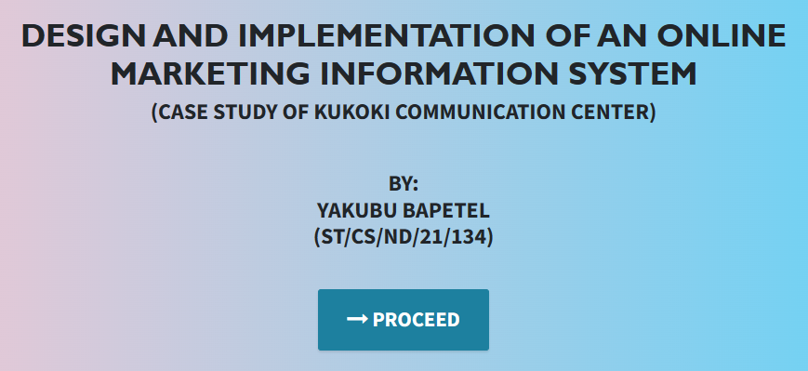

Figure 4.1: Welcome Interface

The above figure 4.1 shows the welcome page of the system, the welcome page is the first page that displays on opening the program.

## 4.2.2 Login Interface

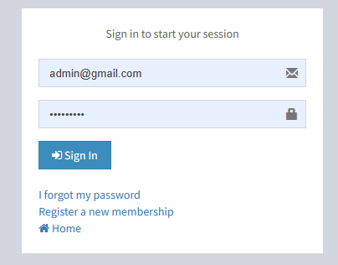

Figure 4.2: Login page interface

Figure 4.2 above shows the system login page interface. The login interface allows the users and Administrator to enter his username and password to get access to the system.

## 4.2.3 Registration Interface

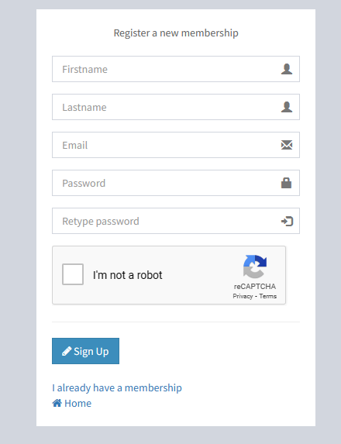

Figure 4.3: Registration Interface

Figure 4.3 above shows where users can register in order to purchase products from the system by filling in the form and confirming his or her email address.

## 4.2.4 Product List interface



Figure 4.4: Product List Interface

Figure 4.4 interface shows the products that are in the system for purchase with their respective prices.

## 4.2.5 Product Interface

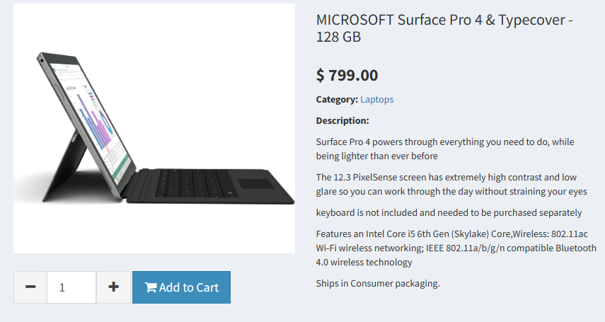

Figure 4.5: Product Interface

Figure 4.5 above displays a particular product that has been selected for purchase showing the quantity required and price.

## 4.2.6 Cart Interface

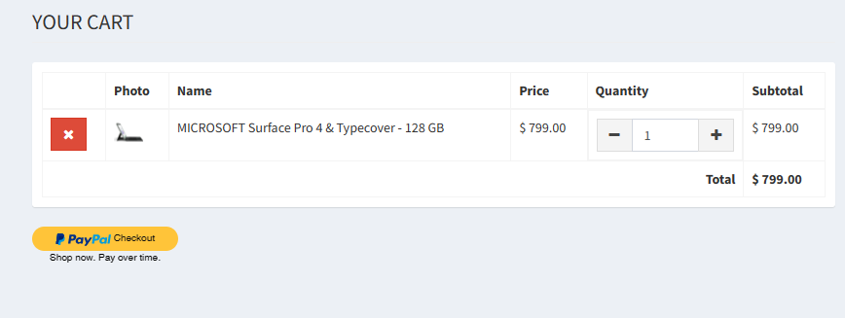

Figure 4.6: Cart Interface

Figure 4.6 above shows the cart interface of the user where all items that have been added to the cart are displayed with their prices and quantity for final payment.

## 4.2.7 Invoice Interface

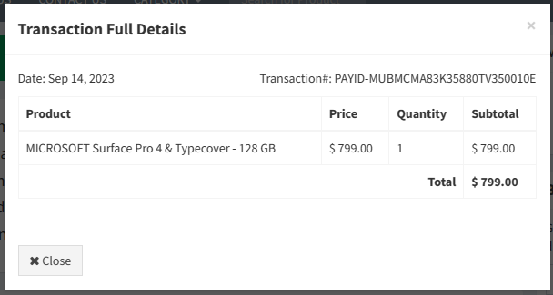

Figure 4.7: Invoice Interface

Figure 4.6 shows the invoice of a particular product that has been paid for with the invoice or payment id on it.

## 4.3 Discussion

Figure 4.1 Welcome Interface: The Welcome Interface is the initial screen that users encounter when they access an application or website. Its primary purpose is to create a positive first impression, provide an introduction to the platform, and guide users on how to proceed further.

Figure 4.2 Login Interface: The Login Interface is where users provide their credentials (username and password) to gain access to the system. It's a critical security checkpoint that ensures only authorized users can use the application or access certain features.

Figure 4.3 Registration Interface: The Registration Interface allows new users to create accounts within the system. Users typically provide personal information and set up login credentials. It's essential for onboarding new users and collecting necessary data for user profiles.

Figure 4.4 Product List Interface: The Product List Interface displays a catalog or list of products available for purchase or exploration. Users can browse through the list to view product details, prices, and other relevant information. It's a fundamental part of e-commerce and online shopping platforms.

Figure 4.5 Product Interface: The Product Interface provides detailed information about a specific product. Users can view product images, descriptions, specifications, and other relevant details. This interface is crucial for users to make informed purchasing decisions.

Figure 4.6 Cart Interface: The Cart Interface is where users can review and manage the items they've selected for purchase. It displays the selected products, quantities, and allows users to add, remove, or adjust items before proceeding to checkout.

Figure 4.7 Invoice Interface: The Invoice Interface generates and displays invoices for users. It includes a summary of the items purchased, their quantities, prices, taxes, and the total amount due. This interface is typically used in e-commerce systems to provide users with a record of their transactions.

These interfaces collectively create a user-friendly and functional system for various purposes, such as e-commerce, online services, or applications. Each interface serves a specific role in guiding users through their interactions with the system and facilitating their tasks efficiently.

## 4.4 User manual

The following are the necessary steps to take in order to use the system efficiently and effectively.

1. Load the url of the system <https://localhost/shops/> the welcome page will be displayed.
2. Click on the **Proceed** button to proceed to the main system.
3. If you created an account, provide your login details by entering your username and password.
4. Depending on the login details provided you will be automatically directed to the dashboard.
5. The various task that you can perform on the portal will be displayed on the sidebar of the dashboard.

# CHAPTER FIVE

# SUMMARY, CONCLUSION AND RECOMMENDATIONS

## 5.1 Summary

The "Design and Implementation of an Online Marketing Information System" is a pivotal study that focuses on enhancing the marketing operations of Kukoki Communication Center through the integration of modern technology. This project explores the development of a user-friendly online platform tailored to the specific needs of the center, providing efficient tools for marketing, customer engagement, and data analysis. The summary offers an overview of the project's objectives, methods, and key findings.

## 5.2 Conclusion

In conclusion, the design and successful implementation of the Online Marketing Information System for Kukoki Communication Center mark a significant milestone in improving its marketing strategies. The system offers streamlined processes for managing marketing campaigns, customer interactions, and data analysis. It enhances customer engagement and decision-making, contributing to the center's competitiveness in the dynamic market landscape. This project underscores the transformative potential of technology in the field of marketing and its positive impact on business operations.

## 5.3 Recommendations

Based on our findings, we recommend the following:

1. Kukoki Communication Center should continue to invest in staff training to ensure efficient utilization of the Online Marketing Information System.
2. Regular system updates and maintenance should be conducted to keep the platform current and secure.
3. The center should consider expanding its online marketing channels and strategies to reach a broader audience.
4. Exploring data analytics and machine learning capabilities for more advanced marketing insights should be considered.

## 5.4 Contribution to Knowledge

This study significantly contributes to knowledge by presenting a real-world case of designing and implementing an online marketing information system. It highlights the importance of technology in streamlining marketing operations, improving customer engagement, and enhancing data-driven decision-making. The project serves as a reference for organizations seeking to leverage online marketing platforms for competitive advantage.

## 5.5 Area for Further Work

There are several areas for further research in this domain:

Evaluating the long-term impact of the Online Marketing Information System on the center's marketing effectiveness and business growth.

Exploring the integration of emerging technologies, such as AI and chatbots, in enhancing customer interactions.

Investigating the scalability of the system for use by other organizations, including those in different industries.

Conducting a cybersecurity assessment to ensure the platform's data security and privacy compliance.

# REFERENCES

Chaffey, D., & Smith, P. R. (2021). Digital Marketing Excellence: Planning, Optimizing and Integrating Online Marketing (7th ed.). Taylor & Francis. This book explores the integration of information systems and technology in the context of digital marketing, emphasizing the importance of data-driven strategies.

Chen, P. P. (2017). The entity-relationship model—toward a unified view of data. ACM Transactions on Database Systems (TODS), 1(1), 9-36. This seminal paper introduces the entity-relationship model, which is fundamental to data modeling and database design principles.

Codd, E. F. (2019). A relational model of data for large shared data banks. Communications of the ACM, 13(6), 377-387. This classic paper presents the relational model, which forms the basis for relational database management systems (RDBMS) commonly used in data ma

Connolly, T., & Begg, C. (2015). Database Systems: A Practical Approach to Design, Implementation, and Management (6th ed.). Pearson. This textbook provides comprehensive insights into database systems, covering topics such as database design, normalization, and database management systems (DBMS).

Elmasri, R., & Navathe, S. B. (2015). Fundamentals of Database Systems (7th ed.). Pearson.

Kaplan, A. M., & Haenlein, M. (2020). Users of the world, unite! The challenges and opportunities of social media. Business Horizons, 53(1), 59-68.

Kaplan, A. M., & Haenlein, M. (2020). Users of the world, unite! The challenges and opportunities of social media. Business Horizons, 53(1), 59-68. This article explores the impact of social media on marketing strategies and discusses the use of marketing information systems for social media analytics.

Kotler, P., & Keller, K. L. (2016). Marketing Management (15th ed.). Pearson.

Kroenke, D. M., & Auer, D. (2016). Database Processing: Fundamentals, Design, and Implementation (14th ed.). Pearson. This textbook delves into the principles of database processing, addressing topics like data modeling, normalization, and database management.

Laudon, K. & Laudon, J. P. (2020). Management Information Systems: Managing the Digital Firm (16th ed.). Pearson.

McDaniel, C., & Gates, R. (2017). Marketing Research (10th ed.). Wiley.

O'Brien, J. A., & Marakas, G. M. (2017). Management Information Systems (11th ed.). McGraw-Hill Education.

Connolly, T., & Begg, C. (2015). Database Systems: A Practical Approach to Design, Implementation, and Management (6th ed.). Pearson.

Daft, R. L. (2017). Management (13th ed.). Cengage Learning.

Ryan, D., & Jones, C. (2019). Understanding Digital Marketing: Marketing Strategies for Engaging the Digital Generation. Kogan Page.

Sheth, J. N., & Sharma, A. (2015). International marketing research: Practices and challenges. Journal of International Marketing, 13(4), 11-28.

Smith, P. R., & Zook, Z. (2019). Marketing Communications: Integrating Offline and Online with Social Media. Kogan Page.

Steinhoff, L., & Palmatier, R. W. (2016). Understanding loyalty program effectiveness: Managing target and bystander effects. Journal of Marketing Research, 53(4), 457-476.

Strauss, J., & Frost, R. (2020). E-Marketing. Routledge.

Tuten, T. L., & Solomon, M. R. (2017). Social media marketing. Sage Publications.

Wind, Y. J., & Mahajan, V. (2017). Digital marketing: A new era in marketing. Journal of Marketing, 81(3), 1-22.

# APPENDIX A

Welcome Interface



Login Interface



Product List interface



Registration Interface



Product Interface



Cart Interface



## Invoice Interface



# APPENDIX B

**PROGRAM CODE**

<!DOCTYPE html>

<html lang="en">

  <head>

    <meta charset="utf-8">

    <meta name="viewport" content="width=device-width, initial-scale=1, shrink-to-fit=no">

    <meta name="description" content="">

    <meta name="author" content="">

    <title>Shopping System</title>

    <!-- Bootstrap Core CSS -->

    <link href="vendor/bootstrap/css/bootstrap.min.css" rel="stylesheet">

    <!-- Custom Fonts -->

    <link href="vendor/font-awesome/css/font-awesome.min.css" rel="stylesheet" type="text/css">

    <link href="https://fonts.googleapis.com/css?family=Source+Sans+Pro:300,400,700,300italic,400italic,700italic" rel="stylesheet" type="text/css">

    <link href="vendor/simple-line-icons/css/simple-line-icons.css" rel="stylesheet">

    <!-- Custom CSS -->

    <link href="css/stylish-portfolio.min.css" rel="stylesheet">

  </head>

  <body id="page-top" style=" background: linear-gradient(90deg, pink, rgb(67, 207, 250));">

    <!-- Header -->

    <header class="masthead d-flex">

      <div class="container text-center">

        <h1 class="mb-2" style="font-size: 45px; font-weight: bolder; font-family: 'Gill Sans', 'Gill Sans MT', Calibri, 'Trebuchet MS', sans-serif; text-transform: uppercase;"><span style=" margin-top:15px;"> DESIGN AND IMPLEMENTATION OF AN ONLINE MARKETING INFORMATION SYSTEM </span> <br>  </h1>

        <h2 class="mb-3" style="">(CASE STUDY OF KUKOKI COMMUNICATION CENTER)</h2><br><br>

        <h2>BY: <br> YAKUBU BAPETEL<br> (ST/CS/ND/21/134)</h2> <br>

        </h3>

        <br>

        <strong><a class="btn btn-primary btn-xl js-scroll-trigger" href="ecommerce/" style="font-size: 30px;"><span class="fa fa-long-arrow-right"></span> PROCEED</a></strong>

        <br> <br> <br>

              </div>

      <div class="overlay"></div>

    </header>

    <!-- Scroll to Top Button-->

    <a class="scroll-to-top rounded js-scroll-trigger" href="#page-top">

      <i class="fa fa-angle-up"></i>

    </a>

    <!-- Bootstrap core JavaScript -->

    <script src="vendor/jquery/jquery.min.js"></script>

    <script src="vendor/bootstrap/js/bootstrap.bundle.min.js"></script>

    <!-- Plugin JavaScript -->

    <script src="vendor/jquery-easing/jquery.easing.min.js"></script>

    <!-- Custom scripts for this template -->

    <script src="js/stylish-portfolio.min.js"></script>

  </body>

</html>

</head><body class="hold-transition skin-blue layout-top-nav">

<div class="wrapper">

  <header class="main-header">

  <nav class="navbar navbar-static-top">

    <div class="container">

      <div class="navbar-header">

        <a href="index.php" class="navbar-brand"><b>Ecommerce</b>Site</a>

        <button type="button" class="navbar-toggle collapsed" data-toggle="collapse" data-target="#navbar-collapse">

          <i class="fa fa-bars"></i>

        </button>

      </div>

      <!-- Collect the nav links, forms, and other content for toggling -->

      <div class="collapse navbar-collapse pull-left" id="navbar-collapse">

        <ul class="nav navbar-nav">

          <li><a href="index.php">HOME</a></li>

          <li><a href="">ABOUT US</a></li>

          <li><a href="">CONTACT US</a></li>

          <li class="dropdown">

            <a href="#" class="dropdown-toggle" data-toggle="dropdown">CATEGORY <span class="caret"></span></a>

            <ul class="dropdown-menu" role="menu">

                      <li><a href='category.php?category=laptops'>Laptops</a></li>

                      <li><a href='category.php?category=desktop-pc'>Desktop PC</a></li>

                      <li><a href='category.php?category=tablets'>Tablets</a></li>

                      <li><a href='category.php?category='>Smart Phones</a></li>

                                </ul>

          </li>

        </ul>

        <form method="POST" class="navbar-form navbar-left" action="search.php">

          <div class="input-group">

              <input type="text" class="form-control" id="navbar-search-input" name="keyword" placeholder="Search for Product" required>

              <span class="input-group-btn" id="searchBtn" style="display:none;">

                  <button type="submit" class="btn btn-default btn-flat"><i class="fa fa-search"></i> </button>

              </span>

          </div>

        </form>

      </div>

      <!-- /.navbar-collapse -->

      <!-- Navbar Right Menu -->

      <div class="navbar-custom-menu">

        <ul class="nav navbar-nav">

          <li class="dropdown messages-menu">

            <!-- Menu toggle button -->

            <a href="#" class="dropdown-toggle" data-toggle="dropdown">

              <i class="fa fa-shopping-cart"></i>

              <span class="label label-success cart_count"></span>

            </a>

            <ul class="dropdown-menu">

              <li class="header">You have <span class="cart_count"></span> item(s) in cart</li>

              <li>

                <ul class="menu" id="cart_menu">

                </ul>

              </li>

              <li class="footer"><a href="cart_view.php">Go to Cart</a></li>

            </ul>

          </li>

                <li class="dropdown user user-menu">

                  <a href="#" class="dropdown-toggle" data-toggle="dropdown">

                    <img src="images/profile.jpg" class="user-image" alt="User Image">

                    <span class="hidden-xs">AKAMSHU EYUAH</span>

                  </a>

                  <ul class="dropdown-menu">

                    <!-- User image -->

                    <li class="user-header">

                      <img src="images/profile.jpg" class="img-circle" alt="User Image">

                      <p>

                        AKAMSHU EYUAH

                        <small>Member since Sep. 2023</small>

                      </p>

                    </li>

                    <li class="user-footer">

                      <div class="pull-left">

                        <a href="profile.php" class="btn btn-default btn-flat">Profile</a>

                      </div>

                      <div class="pull-right">

                        <a href="logout.php" class="btn btn-default btn-flat">Sign out</a>

                      </div>

                    </li>

                  </ul>

                </li>

                      </ul>

      </div>

    </div>

  </nav>

</header>

    <div class="content-wrapper">

      <div class="container">

        <!-- Main content -->

        <section class="content">

          <div class="row">

            <div class="col-sm-9">

                            <div class="box box-solid">

                <div class="box-body">

                  <div class="col-sm-3">

                    <img src="images/profile.jpg" width="100%">

                  </div>

                </div>

              </div>

              <div class="box box-solid">

                <div class="box-header with-border">

                  <h4 class="box-title"><i class="fa fa-calendar"></i> <b>Transaction History</b></h4>

                </div>

                <div class="box-body">

                  <table class="table table-bordered" id="example1">

                    <thead>

                      <th class="hidden"></th>

                      <th>Date</th>

                      <th>Transaction#</th>

                      <th>Amount</th>

                      <th>Full Details</th>

                    </thead>

                    <tbody>